**PROJECT SPECIFICATION**

**Give Your Application Auto-Deploy Superpowers**

**Submitted By Kapil Chaudhary**

# Section 1: Selling CI/CD to your Team/Organization

**CRITERIA: Explain the fundamentals and benefits of CI/CD to achieve, build, and deploy automation for cloud-based software products.**

Presentation has been prepared and detail available in Presentation.pdf file.

# Section 2: Deploying Working, Trustworthy Software

**CRITERIA: Utilize Deployment Strategies to design and build CI/CD pipelines that support Continuous Delivery processes.**

**A public git repository with your project code [URL01]**

**[URL01] -** [**https://github.com/kapilhubgit/cdond-c3-projectstarter.git**](https://github.com/kapilhubgit/cdond-c3-projectstarter.git)

**[URL02] -** [**http://udapeople-139db3a.s3-website-us-east-1.amazonaws.com/#/employees**](http://udapeople-139db3a.s3-website-us-east-1.amazonaws.com/#/employees)

**[URL03] -** [**http://d3283udy6tfw1e.cloudfront.net/#/employees**](http://d3283udy6tfw1e.cloudfront.net/#/employees)

**[URL04] -** [**http://34.205.239.249:3030/api/status**](http://34.205.239.249:3030/api/status)

**[URL05] -** [**http://ec2-100-26-190-7.compute-1.amazonaws.com:9090/alerts**](http://ec2-100-26-190-7.compute-1.amazonaws.com:9090/alerts)

**Build Jobs that failed because of compile errors. [SCREENSHOT01]**

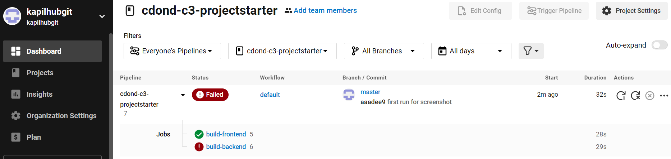

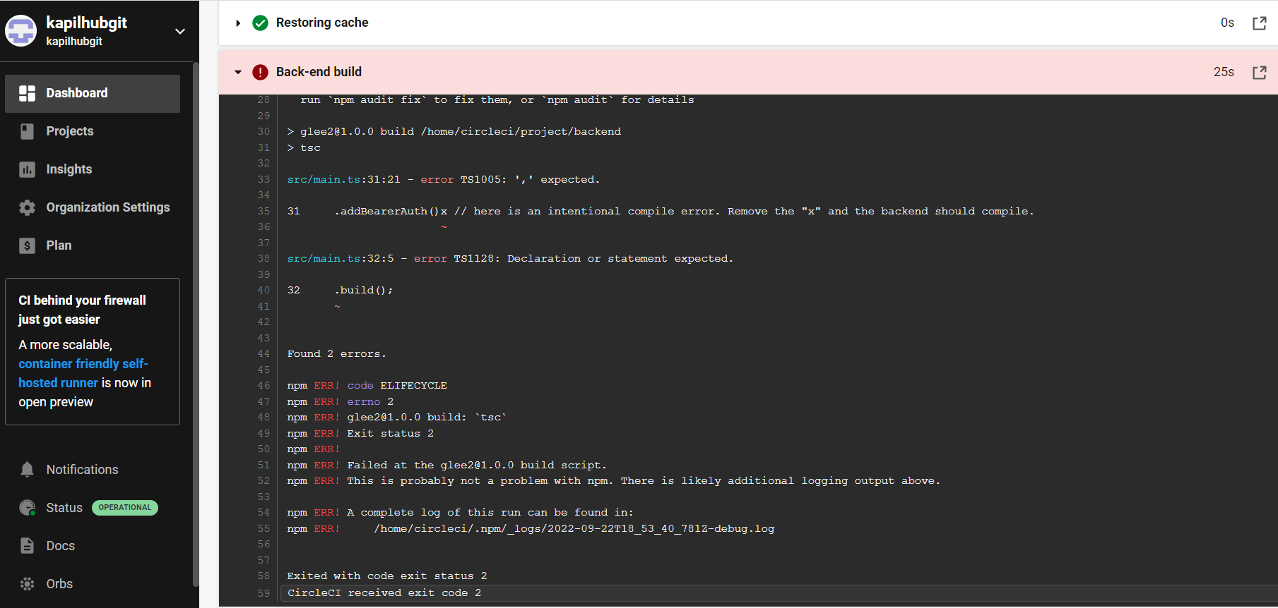

**Failed unit tests. [SCREENSHOT02]**

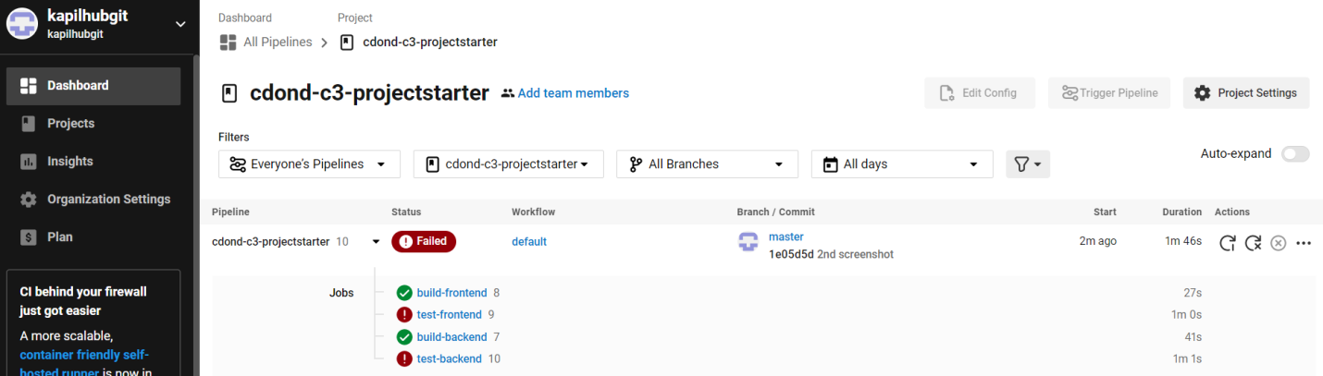

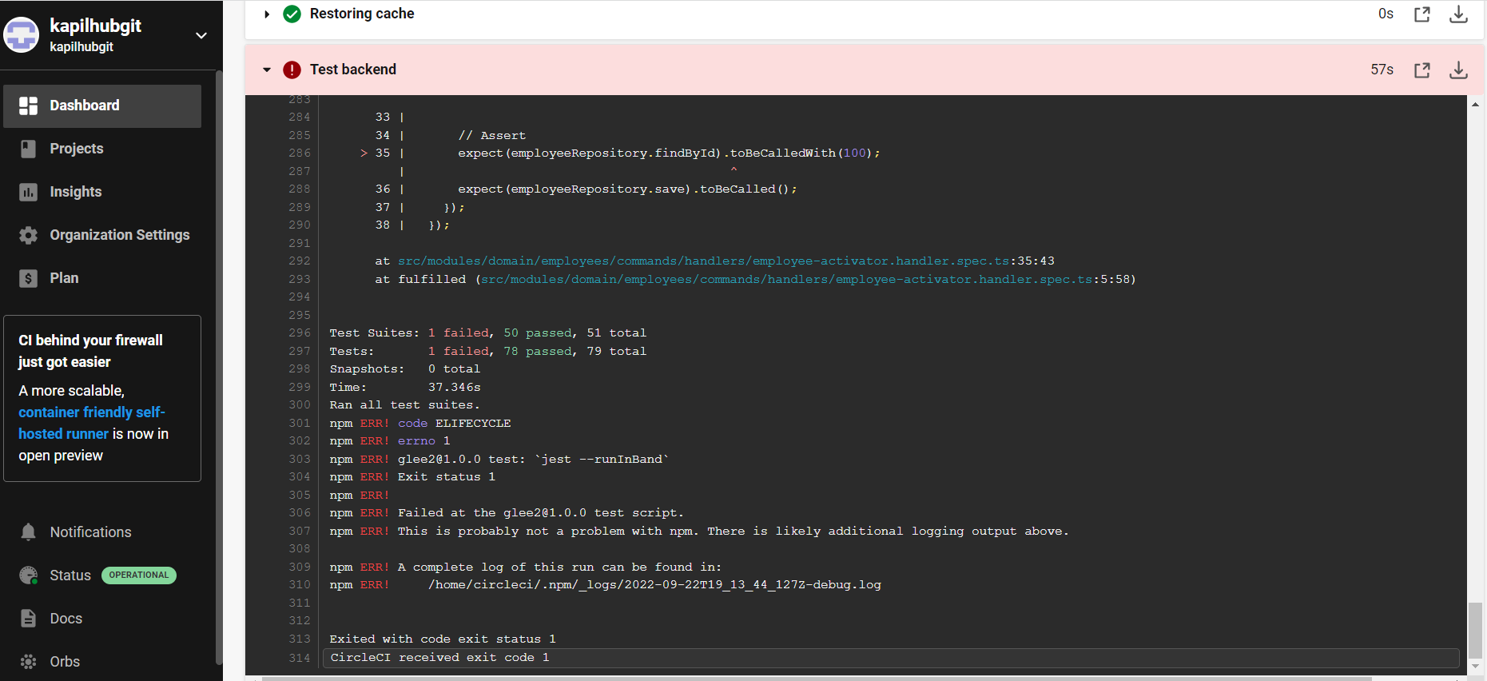

**Failure because of vulnerable packages. [SCREENSHOT03]**

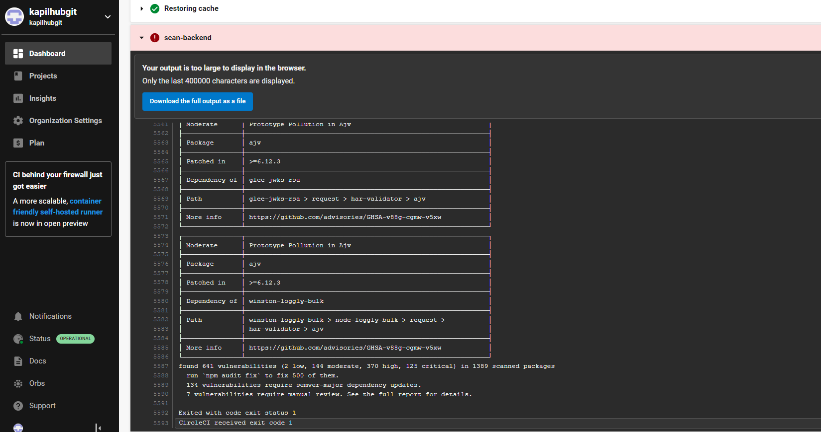

**An alert from one of your failed builds. [SCREENSHOT04]**

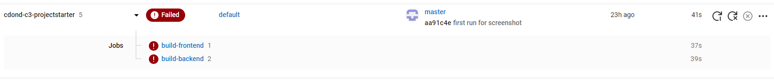

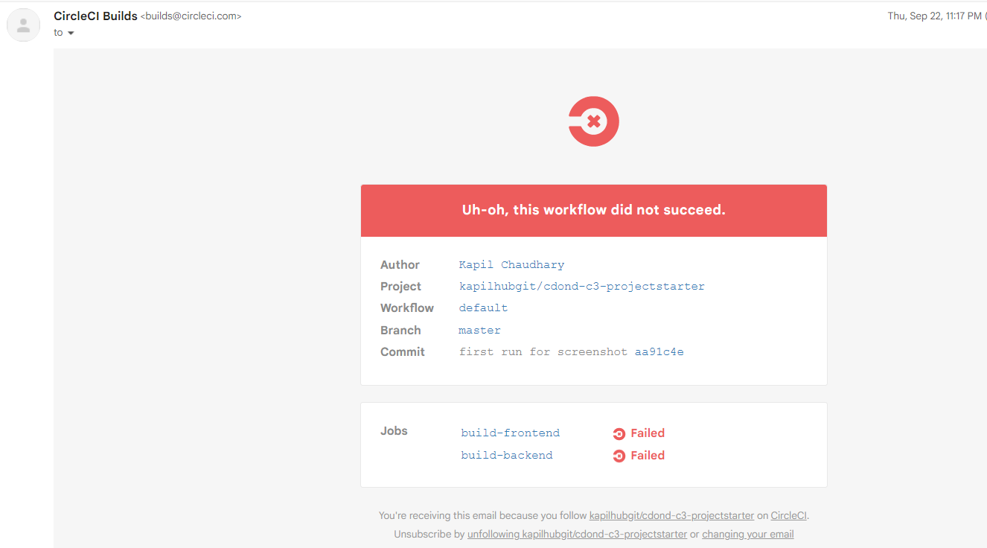

**CRITERIA: Utilize a configuration management tool to accomplish deployment to cloud-based servers.**

**Console output of appropriate failure for infrastructure creation job (using CloudFormation).**[SCREENSHOT05]

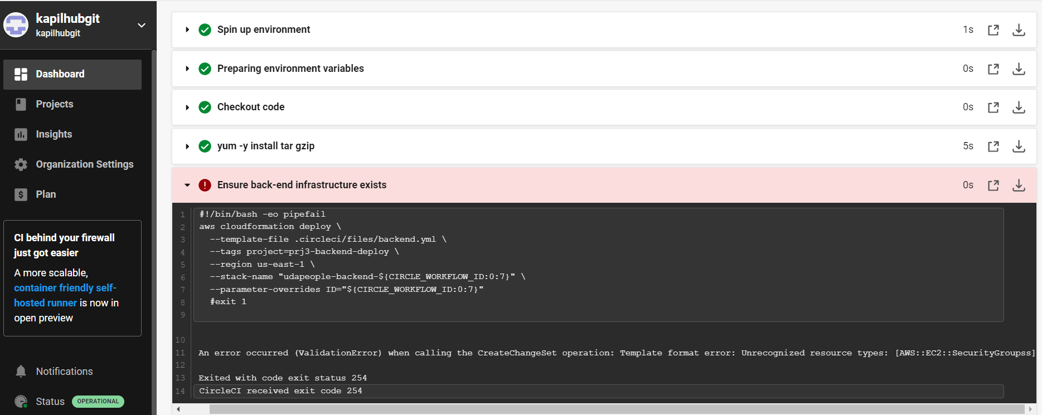

**Console output of a smoke test job that is failing appropriately.**[SCREENSHOT06]

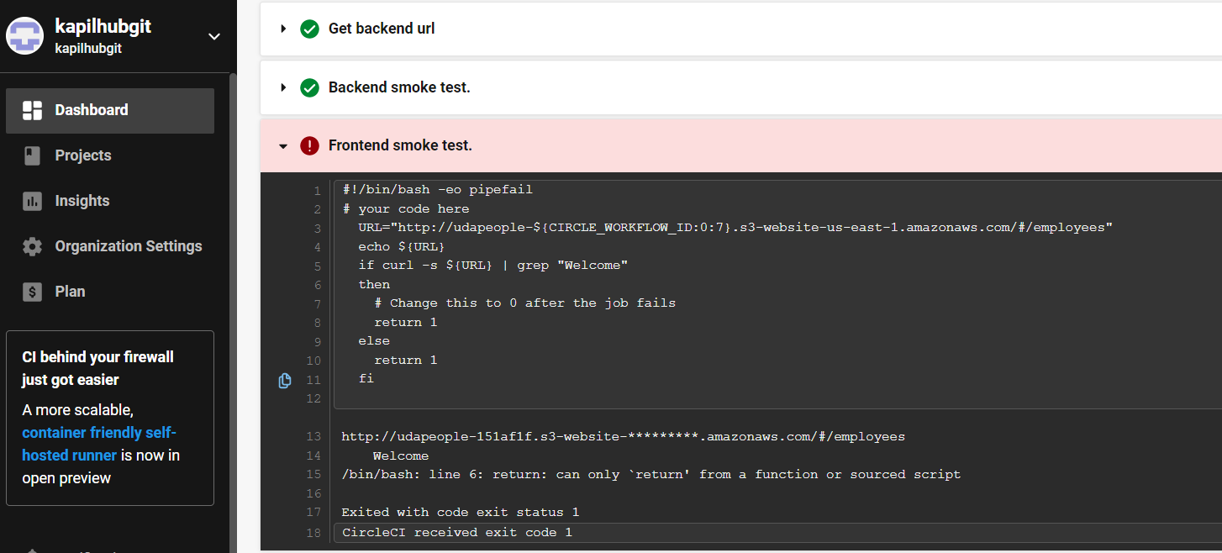

**Console output of a successful rollback after a failed smoke test.**[SCREENSHOT07]

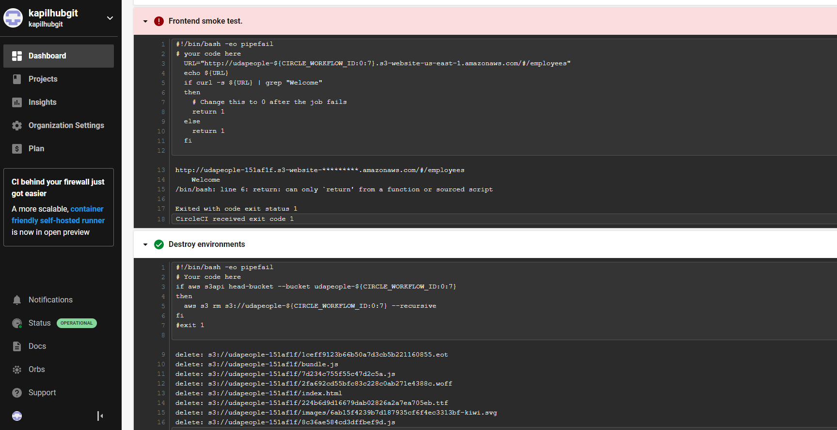

**Console output of successful promotion of new version to production in CloudFront.**[SCREENSHOT08]

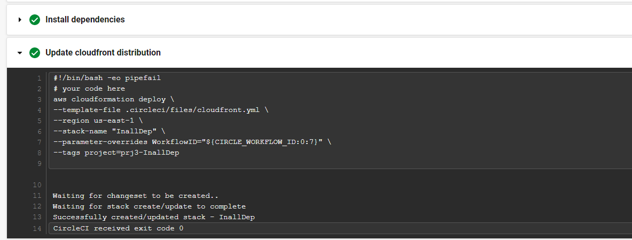

**Console output of successful cleanup job that removes old S3 bucket and EC2 instance.**[SCREENSHOT09]

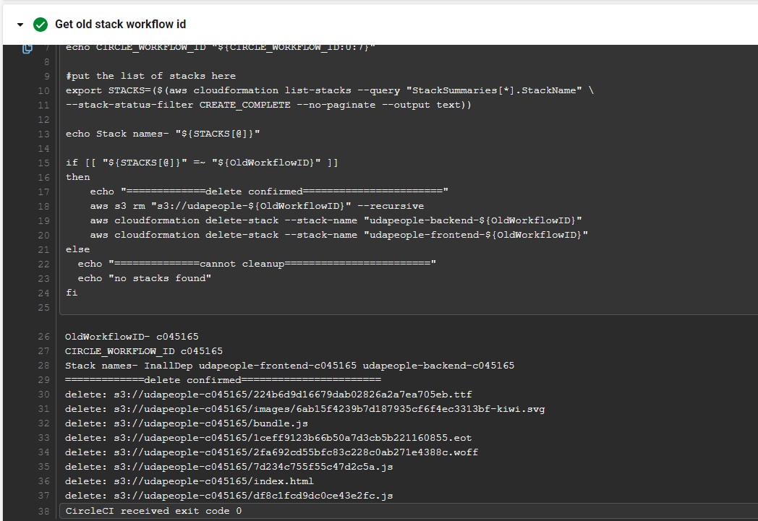

**Evidence that the deploy jobs only happen on the master branch.**[SCREENSHOT10]

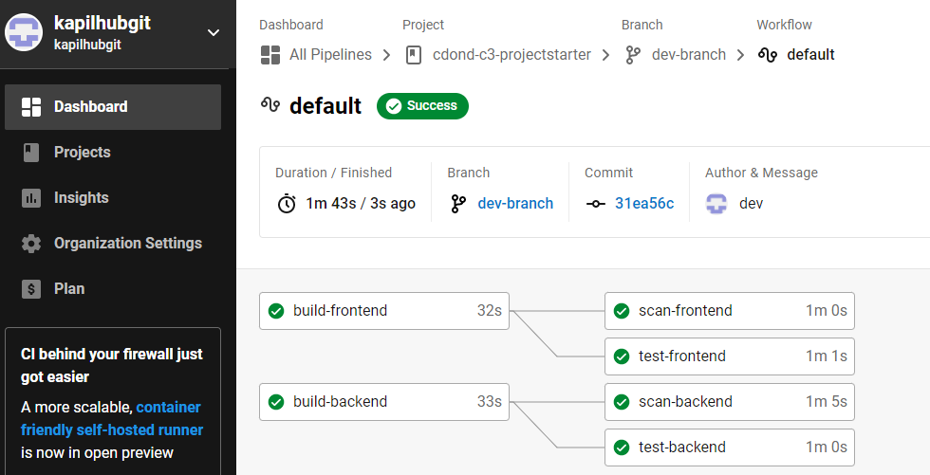

**Evidence of deployed and functioning front-end application in an S3 bucket**[URL02]**.**

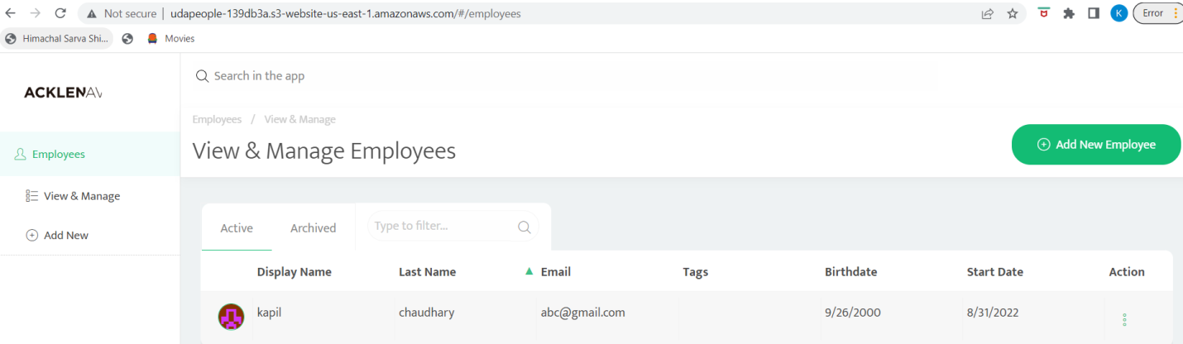

**Evidence of deployed and functioning front-end application in CloudFront.**[URL03_SCREENSHOT]

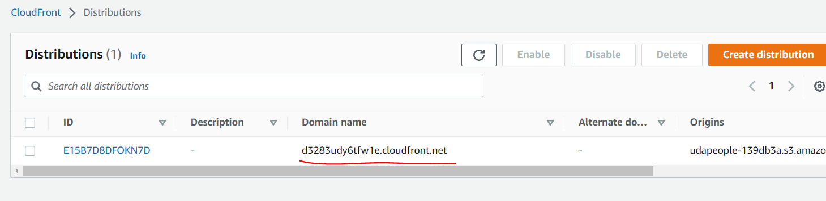

**Evidence of healthy back-end application.**[URL04_SCREENSHOT]

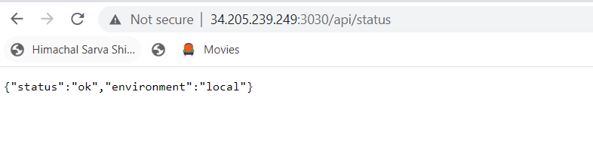

# Section 3: Turn Errors into Sirens

**CRITERIA:Surface critical server errors for diagnosis using centralized logging.**

**Evidence of Prometheus Server.**[URL05_SCREENSHOT]**.**

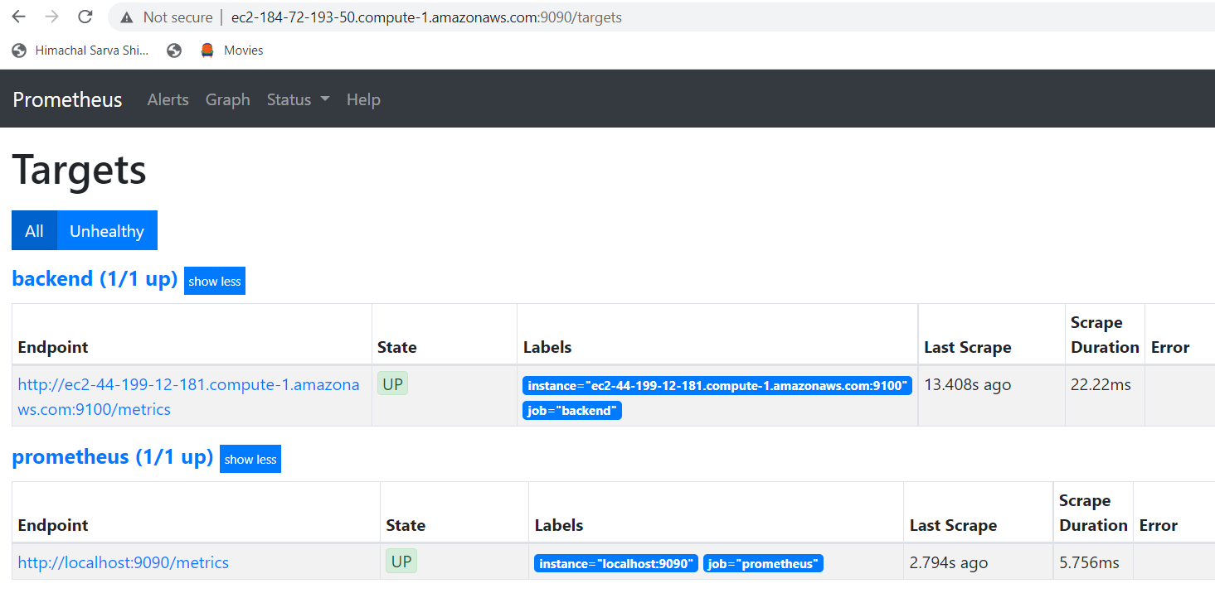

**Evidence that Prometheus is monitoring memory, cpu and disk usage of EC2 instances.**[SCREENSHOT11]

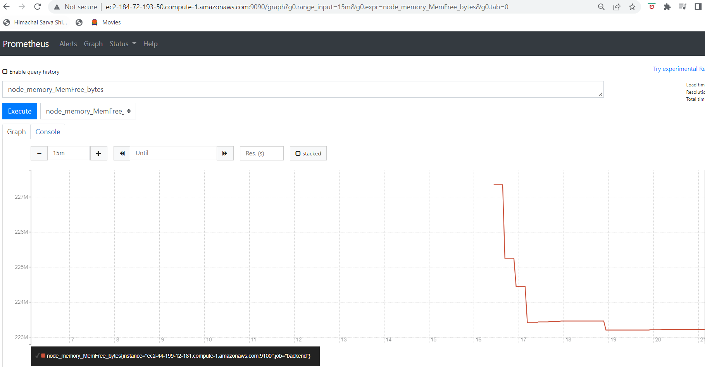

**Evidence that Prometheus and AlertManager send alerts when certain conditions exist in the EC2 instance.**[SCREENSHOT12]

